Devonshire Park Primary School Risk Assessment
RA 029A Full Opening of school v11 18th April 2022

Location or School  Address: Devonshire Park Primary School | Date assessment  Undertaken Friday 18st April | Assessment undertaken by: Jeanne Fairbrother and Jill Billinge
Activity or situation:  RA 029A Full Opening of school v11 18th April 2022 | Review  date: Weekly review or as appropriate for the activity | Signature: 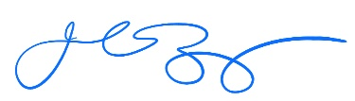

Background information

From 1 April, the government's guidance on living with COVID-19 replaces the DfE's operational guidance for schools.

See [UPDATE] sections.

This applies to all schools, early years settings and FE Colleges.

Legislation and guidance
Health and Safety at Work Act etc. 1974
Management of H&S at Work Regulations 1999
Workplace (Health, Safety and Welfare) Regulations 1992
N.B. All risk assessments referred to within this document have been revised and are available on our website www.jeannefairbrotherassociates.com

1) Hazard / Activity | 2) Who can be harmed and how? | 3) What controls exist to reduce the risk?  Have you followed the hierarchy of controls (eliminate, substitute etc)? | Risk Score  Consequence  X Likelihood | 4) Any further action.  This should be included in the action plan (5), below
UPDATED Failing to have adequate outbreak management/contingency plans to allow for stepping measures up and down. | Staff, pupils, visitors, contractors increased risk of transmission of COVID 19 | - School has updated its School Emergency Plan in line with DfE guidance : Emergency planning and response for education, childcare, and children’s social care settings which includes public health emergencies .  - School will refer to UK Health Security Agency (UKHSA) health protection in education and childcare settings  - Cheshire & Merseyside PHE contact 0344 225 0562  - Greater Manchester Health Protection Unit 0844 225 1295  - NEW DfE incident support helpline (formerly the COVID-19 helpline) is available to support the education sector, with any questions about COVID-19 and other national incidents and emergencies, which impact on education, childcare and children’s social care.  Phone: 0800 046 8687 (M-F 8am to 6pm)  - School will only:  - Consider attendance restrictions as a last resort  - Keep measures to the minimum number of groups possible  - Keep measures for the shortest amount of time possible  - School will take extra steps to manage the transmission of COVID-19 and seek public health advice if the number of positive cases reaches a certain threshold.  - School will follow measures recommended by the Local Authority, Director of Public Health and local protection teams (HPTs) as part of the outbreak management responsibilities. | 3X2=6
Face coverings | Staff, pupils, visitors, contractors increased risk of transmission of COVID 19 | - - Face coverings are no longer advised for pupils, staff and visitors in classrooms or communal areas.  - Staff and pupils should follow wider advice on face coverings outside of school, including on transport to and from school.  - School may be advised by a director of public health that face coverings should temporarily be worn in communal areas or classrooms (by pupils, staff and visitors, unless exempt). School has contingency plans that cover this possibility.  - – any staff who wish to wear a face covering in school will be supported to do so. | 3X2=6
School fails to ensure good hygiene & cleaning standards in school to reduce risk of transmission. | Staff, pupils, visitors, contractors increased risk of transmission of COVID 19 | Hand hygiene -  - School will continue to ensure that staff & pupils maintain high standards of hand hygiene.  - Suitable facilities are provided for individuals to wash/sanitise their hands regularly  Cleaning  - School will maintain appropriate cleaning regimes, using standard products such as detergents with a focus on frequently touched areas. | 3X2=6
Events in school | Staff, pupils, visitors, contractors increased risk of transmission of COVID 19 | - School completes a separate risk assessment for any events held in school following the latest UKHSA guidance | 3X2=6
 | Staff, pupils, visitors, contractors increased risk of transmission of COVID 19 | - When school is in operation, it is well ventilated with comfortable teaching environments.  - Poorly ventilated spaces have been identified | 3X2=6
Close contacts | Staff, pupils, visitors, contractors increased risk of transmission of COVID 19 | - From 24 February, routine contact tracing will end. Contacts will no longer be required to self-isolate or advised to take daily tests.  - Local health teams continue to use contact tracing and provide context-specific advice where they assess this to be necessary as part of their role in managing infectious  - diseases.  - Staff or pupils who are close contacts should:  - avoid contact with anyone who is at higher risk of becoming severely unwell if they are infected with COVID-19, especially those whose immune system means they are at higher risk of serious illness from COVID-19, despite vaccination  - limit close contact with other people especially in crowded, enclosed or poorly ventilated spaces  - wear a well-fitting face covering made with multiple layers or a surgical face mask if you do need to have close contact with other people, or you are in a crowded place  - wash hands frequently with soap and water or use hand sanitiser | 3X2=6
Positive case unaware of new guidance | Staff, pupils, visitors, contractors increased risk of transmission of COVID 19 | - Those with a positive test result will be advised to try to stay at home and avoid contact with other people:  - Staff for 5 days  - Pupils for 3 days  - Both pupils and staff should try to stay home and avoid contact with others if they have symptoms of a respiratory infection and a high temperature or if they feel unwell (returning to school when they feel well enough, and no longer have a high temperature) | 3X2=6
Asymptomatic testing | Staff, pupils, visitors, contractors increased risk of transmission of COVID 19 | - Staff and students in all education and childcare settings are no longer required to carry out twice weekly asymptomatic testing.  - Free testing no longer available for schools and no longer advised in specialist settings  - If there's an outbreak in school, local directors of public health might advise testing for staff, and for pupils of secondary age and above, for a period of time  - Spare tests should be kept and only used if advised by your local health protection team, local authority or director of public health”. | 3X2=6
People at higher risk of becoming seriously unwell from a respiratory infection, including COVID-19  - older people  - those who are pregnant  - those who are unvaccinated  - people of any age whose immune system means they are at higher risk of serious illness  - people of any age with certain long-term conditions  All settings unless indicated | Staff, pupils, visitors, contractors increased risk of transmission of COVID 19 | - School is aware that certain staff and pupils may be at higher risk becoming seriously unwell from respiratory infections.  - People in this category are advised to follow Living safely with respiratory infections including Covid 19  - School will discuss any concerns with employees and parents/carers. And this may form the basis of a personal risk assessment.  - Employees who have received personal advice from their specialist or clinician on additional precautions to take should continue to follow that advice and advise school. | 3X2=6
UPDATE Exams - Special exam considerations for pupils with symptoms or a positive COVID-19 result | Staff, pupils, visitors, contractors increased risk of transmission of COVID 19 | The Joint Council for Qualifications (JCQ) has updated its guidance on special considerations to take account of the latest UK Health Security Agency (UKHSA) guidance  - Pupils continue to follow the wider UK Health and Security Agency (UKHSA) guidance on coronavirus  - Positive Covid test - The UKHSA guidance is that pupils stay at home and avoid contact with others for 3 days (if 18 and under) or 5 days (if 19 or older) after the day they took the test.  - School will advise pupils under 18 years old who are unwell and have a high temperature to stay at home.  - Pupils will only be allowed to return to school “when they no longer have a high temperature”.  - Pupils who only have mild symptoms, such as a runny nose or sore throat, will be advised to attend school to sit exams as long as they are otherwise well.  - Pupils should also continue to attend school if they live with someone who has coronavirus.  - If a pupil still wishes to attend their exam, school follows  UKHSA guidance which is to stay at home and avoid contact with others until they no longer have a high temperature.  - School has informed parents/guardians of school plans in advance of exam dates. | 3X2=6

Risk Rating | Action Required
20 - 25 | Unacceptable – stop activity and make immediate improvements
10 - 16 | Urgent action – take immediate action and stop activity, if necessary, maintain existing controls vigorously
5 - 9 | Action – Improve within specific timescales
3 - 4 | Monitor – but look to improve at review or if there is a significant change
1 - 2 | Acceptable – no further action but ensure controls are maintained & reviewed
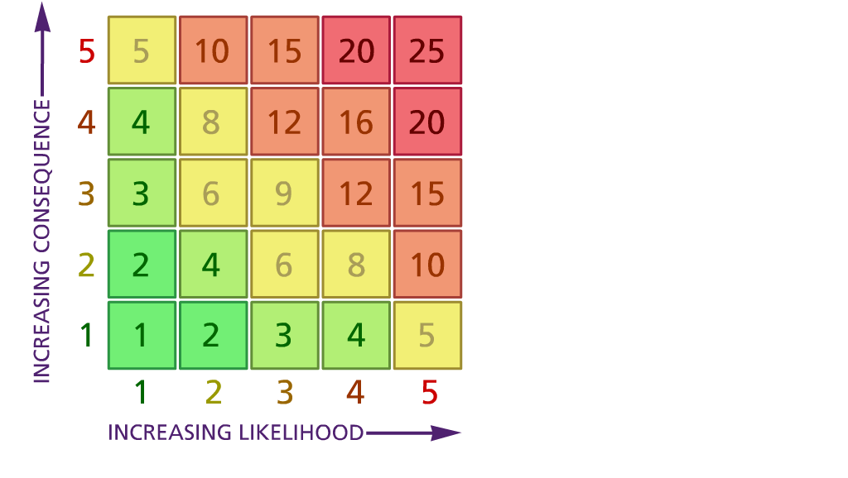
(1) List hazards something with the potential to cause harm here
(2) List groups of people who are especially at risk from the significant hazards which you have identified
- List existing controls here or note where the information may be found. Then try to quantify the level of risk the likelihood of harm arising that remains when the existing controls are in place based on the number of persons affected, how often they are exposed to the hazard and the severity of any consequence. Use this column to list the controls that you might take and develop all or some of that list into a workable action plan. Have regard for the level of risk, the cost of any action and the benefit you expect to gain. Agree the action plan with your team leader and make a note of it overleaf. If it is agreed that no further action is to be taken this too should be noted.

Likelihood: Consequence:

5 – Very likely 5 – Catastrophic

4 – Likely 4 – Major
3 – Fairly likely 3 – Moderate

2 – Unlikely 2 – Minor

1 – Very unlikely 1 – Insignificant

(5) ACTION PLAN
 |  | Responsible | Completed
1 | Circulate the final version to all staff & stakeholders | HT
2
3
4
5
6
7
8
9
10
 | Action plan agreed by (NAME & DATE)

