Pupil premium strategy statement
This statement details our school’s use of pupil premium (and recovery premium for the
2021 to 2022 academic year) funding to help improve the attainment of our disadvantaged pupils.
It outlines our pupil premium strategy, how we intend to spend the funding in this academic year and the effect that last year’s spending of pupil premium had within our school.

School overview
Detail | Data
School name | Devonshire Park Primary School
Number of pupils in school | 441
Proportion (%) of pupil premium eligible pupils | 35%
Academic year/years that our current pupil premium strategy plan covers (3 year plans are recommended) | 2021-2024
Date this statement was published | September 2022
Date on which it will be reviewed | September 2023
Statement authorised by | J. Billinge
Pupil premium lead | M.Nice
Governor / Trustee lead | A. Roberts

Funding overview
Detail | Amount
Pupil premium funding allocation this academic year | £209,360 + £8000 PP+
Recovery premium funding allocation this academic year | £22185
Pupil premium funding carried forward from previous years (enter £0 if not applicable) | £0
Total budget for this academic year  If your school is an academy in a trust that pools this funding, state the amount available to your school this academic year | £239,545

Part A: Pupil premium strategy plan

Statement of intent
Devonshire Park Primary School believes in developing potential and personal success in a happy safe and caring environment. Central to our ethos is the development of individual pupils’ esteem and self-image so that they feel happy, secure, respected and loved. We want to foster a relationship of respect and trust built on a secure, caring environment in which all learning can be sensitively and effectively implemented.
Overcoming barriers to learning is central using The Pupil Premium Grant. Through careful planning and reviews of expenditure, we aim to ensure disadvantaged pupils are given the support and guidance they require to gain academic success.
To prioritise spending we have adopted the EEF tired approach to define our priorities and ensure effective use of the PPG. This comprises of three categories:
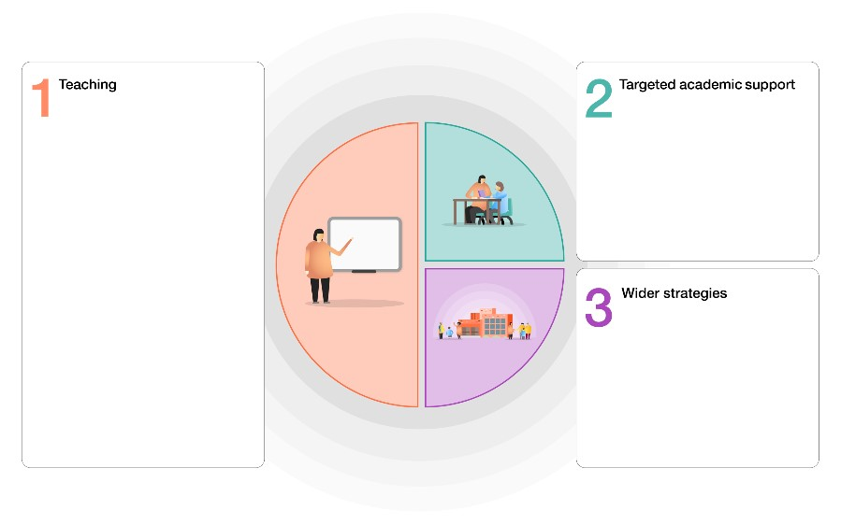
The implementation process
- Explore – Identify priorities and make evidence-informed decisions on the what? Examine the fit for school and our context.
- Prepare – Develop a clear plan identifying the active ingredients and clear implementation outcomes to monitor and evaluate
- Deliver – Support staff and adapt strategies to best support implementation and outcomes
- Sustain – Plan for scaling up and sustaining interventions
Our strategy is also integral to wider school plans for education recovery and is responsive to common challenges pupils face. The approaches complement each other to help maximise outcomes for pupils

Challenges
This details the key challenges to achievement that we have identified among our disadvantaged pupils.
Challenge number | Detail of challenge
1 | Attendance – children fall behind when they do not attend school. Pupils whose attendance is 90% or lower are considered to be persistent absentees (PA). The attendance of pupil premium children last year was 92.2%
2 | Difficulty with Oracy and new vocabulary- Assessments and discussions with pupils would indicate underdeveloped oral language skills and vocabulary gaps. These are evident from reception to KS2
3 | Referrals for pupils and identification of pupils through school referral or Operation Encompass alerts have increased indicating a greater number of children need support with their mental health and well being
4 | Gaps in basic maths skills – internal & external (where available ) assessments indicate attainment amongst disadvantaged pupils is below that of non - disadvantaged

Intended outcomes
This explains the outcomes we are aiming for by the end of our current strategy plan, and how we will measure whether they have been achieved.
Intended outcome | Success criteria
To achieve and sustain improved attendance for all pupils and in particular disadvantaged | Sustained improved attendance in 2022 / 2023 demonstrate
Improve language acquisition using explicit strategies to extend vocabulary in language rich environments and further develop receptive language (VOICE 21) (NELI) | Voice 21 approaches embedded throughout school  More staff are trained to use NELI resources resulting in more children accessing the programme.  Additional staff for SP&L
Pupils and families identified receive targeted support | School has built capacity to support the mental health of pupils and families who are identified in school or have been shown a pathway to support
Improve gaps in basic mathematical concepts | Gaps in pupil mathematical knowledge identified and filled. Increased number of pupils reaching ARE due to high quality interventions

Activity in this academic year
This details how we intend to spend our pupil premium (and recovery premium funding) this academic year to address the challenges listed above.

Teaching
Budgeted cost: £ 31,777
Activity | Evidence that supports this approach | Challenge number(s) addressed | RAG
NTS test purchased for diagnostic assessments | Diagnostic test analysis gives reliable insight into strengths and gaps. This supports identification of correct intervention and support. | 2, 4
Nearpod platform / google classroom | First day remote learning in place DfE | 1, 2 & 3
Bug club subscription to enable reading at home | EEF findings . Homework has a positive impact on pupil progress | 1, 2, & 3
Oracy 21
Sustaining Mastery in Maths Project | EEF report Improving Mathematics in  Key stage 1& 2  NCETM Prioritisation Guidance | 4
Fund teacher release time to embed key elements of guidance | EEF report Improving Mathematics in  Key stage 1& 2  NCETM Prioritisation Guidance | 4
Nearpod Licence |  | 2, 4
Laptop & software purchased for PP+ |  | 2,4

Targeted academic support (for example, tutoring, one-to-one support structured interventions)
Budgeted cost: £ 146,049

Activity | Evidence that supports this approach | Challenge number(s) addressed | RAG
O.5 additional maths mentor | Tuition targeted at specific needs and knowledge gaps can be effective for small group or one to one catchup EEF guidance one to one and small tuition | 1, 4  Fu
Additional TA support staff to be trained and deliver catch-up numeracy and catch-up numeracy in KS1 &  KS2 | EEF Teaching & Learning Toollkit Evidenced Interventions | 1, 4
Additional Speech & language support purchased and additional TA employed | SLA | 2
Additional TA support and training for F2 NELI | DfE foundation language Intervention | 2
Additional TA support for socially speaking | NHS speech & language | 2
Additional TA support one to one reading | EEF Toolkit | 2, 4
Additional Dyslexia Intervention |  | 2, 4

Wider strategies (for example, related to attendance, behaviour, wellbeing)
Budgeted cost: £ 70,008
Activity | Evidence that supports this approach | Challenge number(s) addressed | RAG
Pupils who have an identified mental health need identified and  referred to Place2be,  MHST or the ADHD  Foundation | MHST Trailblazer mental health support | 3
Home school link worker employed  fulltime | In school evidence that early intervention improves attendance | 3
Place2be pupil counselling | Interventions have identifiable impact on attitudes to learning and social relationships in school  EFF Social & emotional Learning | 3
Place2be family support worker | Interventions have identifiable impact on attitudes to learning and social relationships in school  EFF Social & emotional Learning | 3

Total budgeted cost: £ 247,834

Part B: Review of outcomes in the previous academic year

Pupil premium strategy outcomes
This details the impact that our pupil premium activity had on pupils in the 2021 to 2022 academic year.
The effect of the pandemic has had an impact on children’s resilience and mental health and as a consequence attainment. Focussed NTP tutoring and Tutoring from an Academic Mentor has helped fill gaps in learning and pupil confidence in mathematics in year 2,3,4,5,6. Small group work has supported pupils in Foundation and year 1 to make sustained progress in phonics. Good level of development at the end of the Foundation Stage recorded 50% overall reached the standard and (37.5% Pupil Premium). The number of Year 1 pupils who achieve the required mark in the phonics screening check was 81%% of pupils entitled to (78% Pupil Premium). At the end Key Stage 1, 70% gained the expected standard in reading (74% pupil premium). In writing 64% attained the standard (57% of pupil premium). 80% of pupils reached expected standard in Maths (74% Pupil Premium)
At the end of Key Stage 2 53% of pupils reached age expected in reading (41%Pupil Premium) 46% in Writing (43% Pupil Premium). 43% of pupils reached expected in Maths (31%Pupils Premium).
Attendance

Externally provided programmes
Please include the names of any non-DfE programmes that you purchased in the previous academic year. This will help the Department for Education identify which ones are popular in England
Programme | Provider
Pupil and Family Councellors | Place2be

Service pupil premium funding (optional)
For schools that receive this funding, you may wish to provide the following information:
Measure | Details
How did you spend your service pupil premium allocation last academic year? | Pupil received Place2be Place2talk
What was the impact of that spending on service pupil premium eligible pupils? | Developed her ability to form friendship groups

Further information (optional)
Use this space to provide any further information about your pupil premium strategy. For example, about your strategy planning, or other activity that you are implementing to support disadvantaged pupils, that is not dependent on pupil premium or recovery premium funding.

