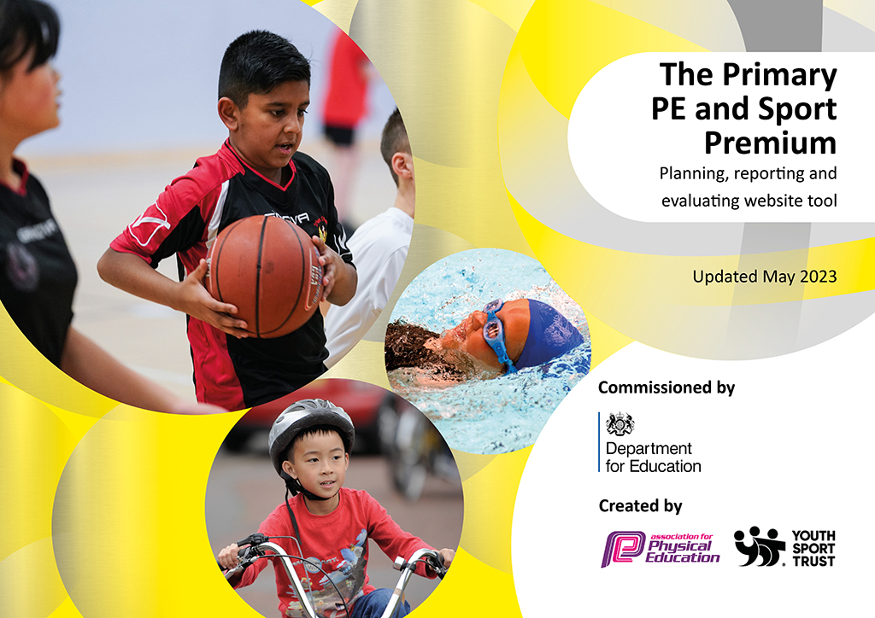
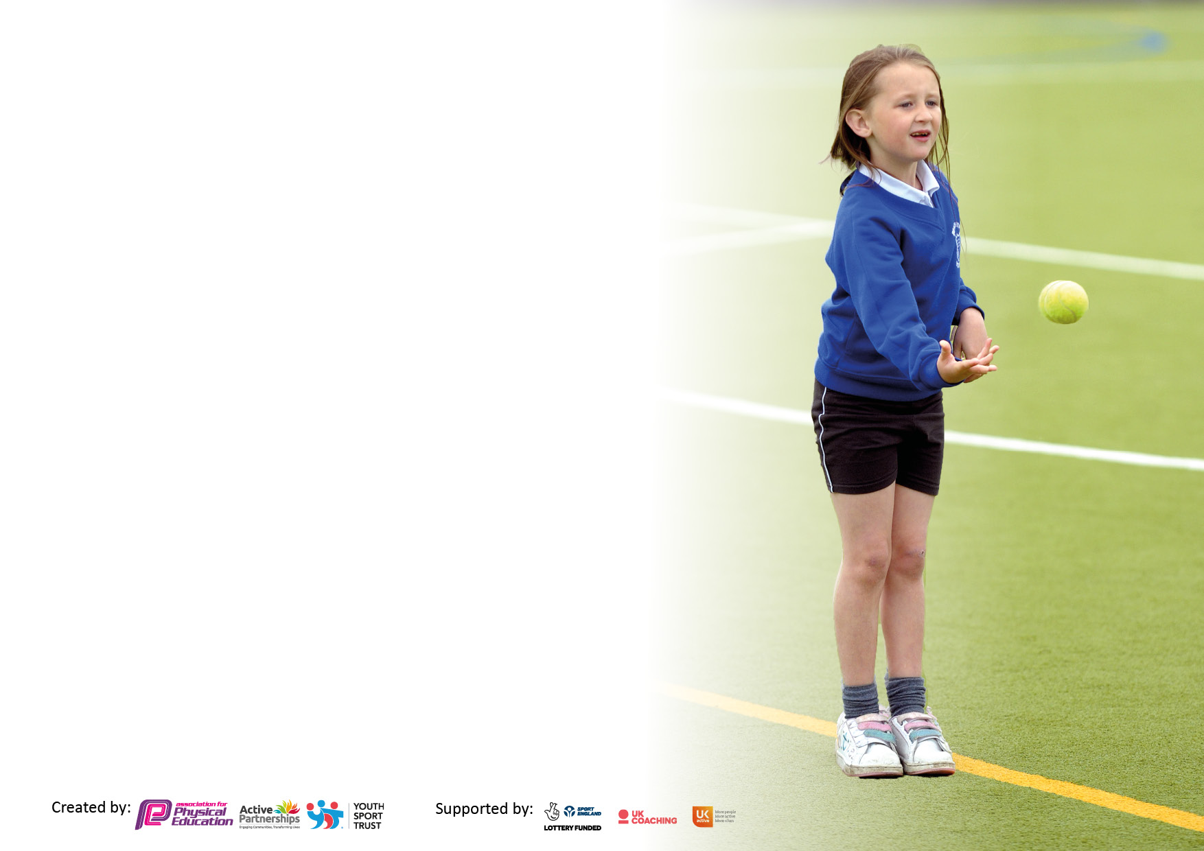

It is important that your grant is used effectively and based on school need. The Education Inspection Framework makes clear there will be a focus on ‘whether leaders and those responsible for governors all understand their respective roles and perform these in a way that enhances the effectiveness of the school’.

Under the Quality of Education Ofsted inspectors consider:
Intent - Curriculum design, coverage and appropriateness
Implementation - Curriculum delivery, Teaching (pedagogy) and Assessment
Impact - Attainment and progress

To assist schools with common transferable language this template has been developed to utilise the same three headings which should make your plans easily transferable between working documents.

Schools must use the funding to make additional and sustainable improvements to the quality of Physical Education, School Sport and Physical Activity (PESSPA) they offer. This means that you should use the Primary PE and sport premium to:

- Develop or add to the PESSPA activities that your school already offer
- Build capacity and capability within the school to ensure that improvements made now will benefit pupils joining the school in future years
- The Primary PE and sport premium should not be used to fund capital spend projects; the school’s budget should fund these.

Pleasevisitgov.ukfortherevisedDfEguidanceincludingthe5keyindicatorsacrosswhichschoolsshoulddemonstrate animprovement.Thisdocumentwillhelpyoutoreviewyourprovisionandtoreportyourspend.DfEencouragesschools to use this template as an effective way of meeting the reporting requirements of the Primary PE and Sport Premium.

We recommend you start by reflecting on the impact of current provision and reviewing the previous spend.

Schools are required to publish details of how they spend this funding, including any under-spend from 2021/2022, as well as on the impact it has on pupils’ PE and sport participation and attainment. All funding must be spent by 31st July 2023.

We recommend regularly updating the table and publishing it on your website throughout the year. This evidences your ongoing self-evaluation of how you are using the funding to secure maximum, sustainable impact. Final copy must be posted on your website by the end of the academic year and no later than the 31st July 2023. To see an example of how to complete the table please click HERE.

DEVONSHIRE PARK PRIMARY SCHOOL

SPORTS PREMIUM 22/23

Total amount carried over from 2021/22 | £0
Total amount allocated for 2021/22 | £18,962
How much (if any) do you intend to carry over from this total fund into 2022/23? | £0
Total amount allocated for 2022/23 | £20,022
Total amount of funding for 2023/23. To be spent and reported on by 31st July 2023. | £19,943
Swimming Data
Please report on your Swimming Data below.

Meeting national curriculum requirements for swimming and water safety.

N.B. Complete this section to your best ability. For example you might have practised safe self-rescue techniques on dry land which you can then transfer to the pool when school swimming restarts.
Due to exceptional circumstances priority should be given to ensuring that pupils can perform safe self rescue even if they do not fully meet the first two requirements of the NC programme of study
What percentage of your current Year 6 cohort swim competently, confidently and proficiently over a distance of at least 25 metres?  N.B. Even though your pupils may swim in another year please report on their attainment on leaving primary school at the end of the summer term 2022.  Please see note above | 48 %
What percentage of your current Year 6 cohort use a range of strokes effectively [for example, front crawl, backstroke and breaststroke]?  Please see note above | 48 %
What percentage of your current Year 6 cohort perform safe self-rescue in different water-based situations? | 88 %
Schools can choose to use the Primary PE and sport premium to provide additional provision for swimming but this must be for activity over and above the national curriculum requirements. Have you used it in this way? | Yes/No

Action Plan and Budget Tracking
Capture your intended annual spend against the 5 key indicators. Clarify the success criteria and evidence of impact that you intend to measure to evaluate for pupils today and for the future.

Academic Year: 2022/23 | Total fund allocated: | Date Updated:
Key indicator 1: The engagement of all pupils in regular physical activity – Chief Medical Officers guidelines recommend that primary school pupils undertake at least 30 minutes of physical activity a day in school |  |  |  | Percentage of total allocation:
 |  |  |  | 16.7%
Intent | Implementation |  | Impact
Your school focus should be clear what you want the pupils to know and be able to do and about  what they need to learn and to  consolidate through practice: | Make sure your actions to achieve are linked to your intentions: | Funding allocated: | Evidence of impact: what do pupils now know and what can they now do? What has changed?: | Sustainability and suggested next steps:
Introduction of an Active Playground Leader to plan and implement active playground sessions to engage all children during lunchtimes to support our aim of helping children to be physically active for 60 minutes per day | Full Of Beans employee Amanda Smale (and Danny Ward) employed to work with Playground Sports Leaders to plan for and set up equipment to enable children to be physically active during lunchtimes. | £ 3350 | 12 playground leaders engaged in implementing and running structured lunchtime games.  263 children each playtime had access to a range of structured playground games and activities such as Volleyball, Tag Games, Dodgeball as well as pupil-suggested games and activities such as “One Bounce” | Continue to improve Active Playground provision led by Playground Sports Leaders  Use of Full Of Beans and Ian Colligan to target SEND pupils to tackle attendance, self-regulation and ADHD using sensory circuits, reward sessions and motivational activity  ShadowDance to run training for Zumba leaders using Silent Disco equipment and lead lunchtime Zumba sessions for all KS2 pupils
Key indicator 2: The profile of PESSPA being raised across the school as a tool for whole school improvement |  |  |  | Percentage of total allocation:
 |  |  |  | 12.4 %
Intent | Implementation |  | Impact
Your school focus should be clear what you want the pupils to know and be able to do and about  what they need to learn and to  consolidate through practice: | Make sure your actions to achieve are linked to your intentions: | Funding allocated: | Evidence of impact: what do pupils now know and what can they now do? What has changed?: | Sustainability and suggested next steps:
Introduction of weekly x 1 hour physical literacy session for both Foundation classes led by Full Of Beans.  Through anecdotal evidence, the F1 and 2 staff noticed that the children’s motor skills were impacted by Covid restrictions. We wanted children to have extra coaching to enable them to improve fundamental skills | Liam from Full of Beans delivers x 2 hour weekly Fundamental Skills sessions to F2 children supporting and improving their physical literacy (co-ordination) | £ 2484 | 45 pupils’ motor skills have improved and they are all able to hop, skip, throw with one or two hands at a target. Teachers have noted a huge improvement in their movement skills and they are clearly participating in activity willingly and enthusiastically.  Staff have used this as CPD and now feel confident in delivering these sessions themselves next year in PE lessons | Continue to provide Fundamental skills session next year. Make a Baseline assessment and assess against the Baseline to give solid evidence of progress.  Improvement of playtime facilities for KS1 playground.  Purchase of equipment

Key indicator 3: Increased confidence, knowledge and skills of all staff in teaching PE and sport |  |  |  | Percentage of total allocation:
 |  |  |  | 42.7%
Intent | Implementation |  | Impact
Your school focus should be clear | Make sure your actions to | Funding | Evidence of impact: what do | Sustainability and suggested
what you want the pupils to know | achieve are linked to your | allocated: | pupils now know and what | next steps:
and be able to do and about | intentions: |  | can they now do? What has
what they need to learn and to |  |  | changed?:
consolidate through practice:
Introduction of a new, whole-school Edsential Scheme of Work for PE  Children will have a scheme taught by teachers which shows progression of skills throughout the school  Staff will be confident in delivering the new scheme of lessons and understand how their teaching fits within the whole scheme.  Children will feel confident and make good progress, but also forge a lifelong love of PE and physical activity | CPD arranged and delivered by Edsential company to enable the introduction of the new whole-school Edsential PE scheme  Staff survey to be completed to assess confidence and competence; modelling of Games lessons to support less confident staff; Staff Meeting to introduce long, medium and short term planning  FULL DAY INSET- coaching of gymnastics  Staff Meeting to introduce the new scheme  Half-termly focused CPD for staff members in response to staff survey in response | £ 8555 | Nine staff have received a half term of CPD from Sarah Phelan modelling and team teaching PE sessions and supporting teachers with coaching strategies  Google Forms survey completed by staff (see below) evaluating their confidence in the new scheme  https://drive.google.com/file/d/12MVt9kgjgYjrNK8lNSbqzTos1nhbWTpe/view?usp=drive_link  “I feel more confident teaching gymnastics. Sarah showed me a lot of ways of delivery gymnastics safely.” D.E.  “It was great observing from the outside in. It made it much easier to see how I can structure my lessons in the future. Sarah's  knowledge of gymnastics was fantastic.” D.W.  “I feel more confident about the structure of the lesson and how to differentiate better. The children are now having more fun and I  feel I can support them better to improve.” J.C.  Staff feel confident to begin teaching the new Edsential scheme next year, but most would benefit from Gymnastics CPD before Spring term 2023 and also request extra resources to supplement the plans | Monitor the teaching of PE and assessment of PE using the new scheme and implement further CPD to cover Dance and gymnastics.  Get Pupil and Parent Voice on the range of Games provided  CPD ShadowDance Dance curriculum for new staff especially ECT staff  CPD for assessment of PE for all. Edsential 1 x hour Staff Meeting. Alex Barnes to deliver whole school staff meeting to improve assessment of PE  Continue half-termly CPD team teaching in PE lessons for two staff every half term, focusing on ECT and new teachers
Key indicator 4: Broader experience of a range of sports and activities offered to all pupils |  |  |  | Percentage of total allocation:
 |  |  |  | 28.1 %
Intent | Implementation |  | Impact
Your school focus should be clear | Make sure your actions to | Funding | Evidence of impact: what do | Sustainability and suggested
what you want the pupils to know | achieve are linked to your | allocated: | pupils now know and what | next steps:
and be able to do and about | intentions: |  | can they now do? What has
what they need to learn and to |  |  | changed?:
consolidate through practice:
Additional achievements:  Weekly after-school Year 3-6 Dance Club run by Shadow Dance company  Prenton Tennis  Cheshire Cricket  Cheshire Phoenix- Hoops For Health  Introduction of badminton equipment and nets for curriculum and extra-curricular activities  Full Of Beans extra-curricular clubs | 1x 60 minute Dance Club for Year 3 and 4 children leading to participation IN Wirral Dance Festival at Floral Pavilion theatre  Both curriculum and after-school clubs for Year 1, 2 and F2s  Organise a Talent Identification Day to encourage children to join the club  Both curriculum and after school clubs delivered by Cheshire Cricket coaches for Year 2 and Year 5 classes  Hoops for Health assembly, carousel of healthy lifestyle sessions and coaching leading to competition at EPSV; also includes a day out at a Cheshire Phoenix match  Badminton equipment and nets purchased  Full Of Beans to deliver a wide range of extra-curricular clubs across every year group in school | £ 1630  £ 510  £ 600  £ 350  £ 383  £2160 | 18 Year 3 and 4 children attended after-school Dance sessions and performed in front of an audience of 800 people at the Floral Pavilion as part of a Wirral Schools Dance event.  14 Year 5 and 6 children attended after-school Dance sessions and performed in front of an audience of 800 people at the Floral Pavilion as part of a Wirral Schools Dance  40 children took part in Tennis After School clubs and F2 children were part of a Talent Identification event. Two children have joined Prenton Tennis Club as a result  60 Year 2 children attended weekly cricket coaching sessions delivered by Cheshire Cricket coaches. Small sided, intra-school competitions were organised.  81 Year 6 children benefitted from coaching and Hoops For Health scheme. 16 children used the Cheshire Phoenix Season Ticket to attend games  18 children went on to compete in inter-school competition with Rock Ferry Primary  20 After-school club members have regularly used the badminton equipment for leisure and competitive games  Badminton has been implemented into the new PE curriculum and all 87 Year 6 children have used the equipment in lessons  307/494 children have taken part in Full Of Beans extra-curricular clubs each term throughout the year | Maintain and strengthen links with ShadowDance company  to build towards Wirral Dance Festival. CPD provided. Zumba Leaders to support Active Playground  Contact has been made to continue all clubs next year.  Nic Gore from Prenton High has offered to work with DPPS to provide Volleyball coaching  and the use of the facilities for inter-school competition for our Cluster  Maintain links with Prenton |Tennis Club and use their facilities for inter-school cluster events next year.  Encourage more children to attend the tennis club regularly  Maintain links with Cheshire Cricket and re-arrange curriculum and after-school coaching opportunities.  Link to Wirral School Games competition and inter-school competition  Maintain links and re-arrange curriculum and after-school coaching opportunities.  Link to Wirral School Games competition  Expand links with Rock Ferry Primary for intra-school events  Arrange for badminton CPD or after school clubs next year  Offer a wider range of clubs responding to pupil and parent voice surveys  Google Forms Parent and Student Voice to be sent out to evaluate participation and broaden experiences next year  Purchase of golf equipment for curriculum and outdoor facilities. Use expertise of ECT Erin Toft, golf champion player

Key indicator 5: Increased participation in competitive sport |  |  |  | Percentage of total allocation:
 |  |  |  | (See Full Of Beans funding Key Indicator 4 %
Intent | Implementation |  | Impact
Your school focus should be clear | Make sure your actions to | Funding | Evidence of impact: what do | Sustainability and suggested
what you want the pupils to know | achieve are linked to your | allocated: | pupils now know and what | next steps:
and be able to do and about | intentions: |  | can they now do? What has
what they need to learn and to |  |  | changed?:
consolidate through practice:
Full Of Beans company will deliver after-school coaching to prepare children for inter and intra school competition | 3 x 60 minute weekly after-school clubs to be delivered by Full Of Beans to prepare children for inter and intra school competition. Clubs to be arranged and targeted to lead up to Wirral School Games, Cluster and other local competitive events (Mr Croucher/Mrs Giddens) | £ (See Full Of Beans funding Key Indicator 4) | More than 307 (66%) children have attended FREE after-school activities leading to competition.  We offered Boccia and New Age Kurling to target Inclusive activities and target children who might benefit from Inclusive activities  Many clubs have been designed to prepare for competition: basketball, gymnastics, cricket, football | Work with other companies to extend the offer of a wider range of activities such as Boxercise delivered by Ian Colligan  Extend the range of opportunities for different activities for SEND children through Full Of Beans.  Get Pupil and Parent Voice to improve the offer and range of activities

Signed off by
Head Teacher:
Date:
Subject Leader:
Date:
Governor:
Date:

